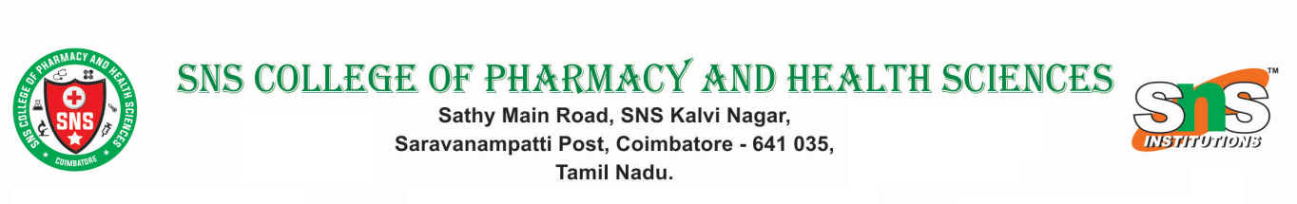

ANTI-RAGGING COMMITTEE

S.NO | Name of the Member | Designation | Contact Number
1 | Dr. S. Sathesh Kumar | Principal | 9713597175
2 | Police Station | Sub-Inspector | 04222654246
3 | Mr. S. Rudhreshwaran | NGO | 9500810268
4. | Mr. Sivasubramanian P | Teacher Representative | 9487225079
5 | Mrs. Sumathy R | Social Worker | 8300794547
6 | Mr. Sridhar M | Parent | 7598736089
7 | Mrs. Betty Rani | Non-Teaching | 8870810867
8 | Mrs. Vanaja | Rector (Ladies Hostel) | 9894922033
9 | Mr. Saravanan D | Rector (Boys Hostel) | 8122426035
10 | Mr. Ashwwin U | Student | 8072083747
11 | Ms. Bharani K P | Student | 9943241068
12 | Ms. Yamuna | Student | 9345376826

